PLOS Formatting Requests

# For: "Sensory processing in humans and mice fluctuates between external and internal modes"

As a Latex submission, please provide the .TEX file for your manuscript along with an updated reference PDF marked up with the changes you have made. **Please ensure your final .TEX file does not contain marked changes as this is the file that will be used for typesetting. Please note that PLOS staff are not able to make formatting changes or edits to LaTex files on your behalf. All changes must be made yourself; please ensure you update both the .tex file as well as the PDF.**

To access your manuscript and complete these changes, please follow the link in the email we sent you. You will find the submission in "Current Task Assignments", and will need to click "Submit Task" in order to upload your corrected file(s).

**This is the FINAL stage for you to copyedit your manuscript and figure files.** We strongly recommend that all authors double check ALL files prior to the final versions being submitted. Changes to the manuscript, statements, author list, references, equations, or figures, including resizing, at the proof stage WILL NOT BE ACCEPTED.

**Questions?** Email [plosbiology@plos.org](mailto:plosbiology@plos.org) quoting your manuscript number.

# METADATA CHECK

Please confirm that the following information is correct and contact us if any changes are necessary. This information will be indexed in PubMed and published by *PLOS Biology* as you have written them.

* An **Early Version** of your manuscript:
  + WILL be published online ahead of the final version

If you (or your institution) are planning a press release for this article, please contact us as soon as possible to ensure that an early version of your paper is not published.

* Your **financial disclosure** will be typeset as follows: **Thank you, amended in the system.**
  + VW was funded by the Leopoldina Academy of Sciences (grant number: LDPS2022-16, https://www.leopoldina.org/en/leopoldina-home/) and the German Research Foundation DFG (grant number: STE 1430/8-1, https://www.dfg.de)

VW and HS were funded by the Berlin Institute of Health Clinician Scientist Program (https://www.bihealth.org/en/translation/innovation-enabler/academy/bih-charite-clinician-scientist-program).

PS was funded by the German Research Foundation DFG (grant number: STE 1430/8-1, https://www.dfg.de) and the German Ministry for Research and Education (ERA-NET NEURON program, grant number: 01EW2007A, https://www.neuron-eranet.eu/).

The funders had no role in study design, data collection and analysis, decision to publish, or preparation of the manuscript.”

* Your **competing interests** statement will be typeset as follows:
  + The authors have declared that no competing interests exist.
* Your **data availability statement** will be typeset as follows: **Thank you, amended in the system.**

The authors confirm that all data underlying the findings are fully available without restriction. All materials associated with this submission are available on an accompanying Github repository (https://github.com/veithweilnhammer/Modes, DOI: https://zenodo.org/records/10019948). We included all relevant data and code for the generation of the manuscript in the R-Markdown format.

* The details of the **corresponding author** will be typeset as follows:
  + Name: Veith Weilnhammer
  + E-mail: veith.weilnhammer@gmail.com
  + ORCiD: 0000-0002-3332-0006
* Please check the **authorship and affiliations** list on the title page of your manuscript. These details will be used to index the authorship of your manuscript and therefore should be checked carefully for any errors.
* Please ensure that if you have any protocols associated with [protocols.io](https://www.protocols.io/) in your manuscript, they are made public before publication to guarantee immediate access to the methodological details.
* Your **title** will be typeset from the submission system, not the manuscript file. Please check that the following is correct:
  + Sensory processing in humans and mice fluctuates between external and internal modes
* Your **short title** will be typeset from the submission system, not the manuscript file. Please check that the following is correct:
  + Bimodal inference in humans and mice

Please note that if you wish any word in your submission’s title or short title to be **italicised**, this will need to be manually changed in the Editorial Manager system. Please contact the journal office to address this.

Please pay special attention to your Supporting Information files, as these will be published as given. Make sure that all tracked changes, if present, have been accepted before submitting the final versions for publication.

**Dear Veith,**

**Thank you for your patience while we conduct the final review of your manuscript. Thank you for all the formatting changes you have made on your submission.**

**Please also address the last remaining technical issues.**

**Should you need any assistance, please don't hesitate to contact us.**

# MANUSCRIPT REQUIREMENTS

Please update your manuscript with the following changes:

1. Please indicate the corresponding author on the title page with an asterisk (*) and include the corresponding author's email address. Only an asterisk and the email address itself are required.

I have added an asterix to the corresponding author on the title page:

Authors:

Veith Weilnhammer1,2,3,∗ , Heiner Stuke1,2 , Kai Standvoss1 , Philipp Sterzer4

* veith.weilnhammer@gmail.com

1. Please note that Affiliations should include a department (if applicable), an institution, a city, and a country (no postcode). US affiliations should also include the unabbreviated state name. For example: Department of Biomedical Engineering, Johns Hopkins University, Baltimore, Maryland, United States of America.

The affiliations listed on the title page adhere to this formatting. Let us know whether you would like to keep it that way. All associated universities are named by the city, which now appears to times in each affiliation:

* 1 Department of Psychiatry, Charité-Universitätsmedizin Berlin, corporate member of Freie Universität Berlin and Humboldt-Universität zu Berlin, Berlin, Germany
* 2 Berlin Institute of Health, Charité-Universitätsmedizin Berlin and Max Delbrück Center, Berlin, Germany
* 3 Helen Wills Neuroscience Institute, University of California Berkeley, Berkeley, California, United States of America
* 4 Department of Psychiatry (UPK), University of Basel, Basel, Switzerland

1. Regarding submitted and unpublished data in your S1 Table:

Please provide a reference or link to where the data are published.

We now provide a link to the Confidence database in the legend to the Supplemental Item S1 Table:

**S1 Table.** Studies extracted from the Confidence Database (downloaded from https://osf.io/s46pr/)

1. Thank you for updating the in text citations.

We apologize for the unclear request in the FTC letter.

Please use the following examples of naming conventions for citing multiple figures in your manuscript:

- Figs 3 and 4

- Figs 3, 4, and 7

- Figs 1-5

**- Fig 3A and 3B**

**- Figs 3A and 7B**

Or a combination:

- **Figs 1 and S3**

- Figs S3 and 1

- Fig 1 and S3 Dataset

- S1 Fig and S5 and S6 Tables

Thank you, we have checked how we are citing multilpe figures. It should now adhere to this format in the main manuscript (Manuscript_publ.tex/pdf) and S1_Text.pdf.

You can also upload a Striking Image to accompany your article if one is available. If this image is judged to be suitable, it may be featured on our website. Images should be high resolution, eye-catching, single panel images. If your image is from someone other than yourself, please ensure that the artist has read and agreed to the terms and conditions of the [Creative Commons Attribution License](https://creativecommons.org/licenses/by/4.0/).

Note: we cannot publish copyrighted images. When uploading a Striking Image, please also provide a document containing a suitable caption for the image, and appropriate credit to the image’s creator. This document can be uploaded as a second ‘Striking Image’ file type.

We have prepared this fig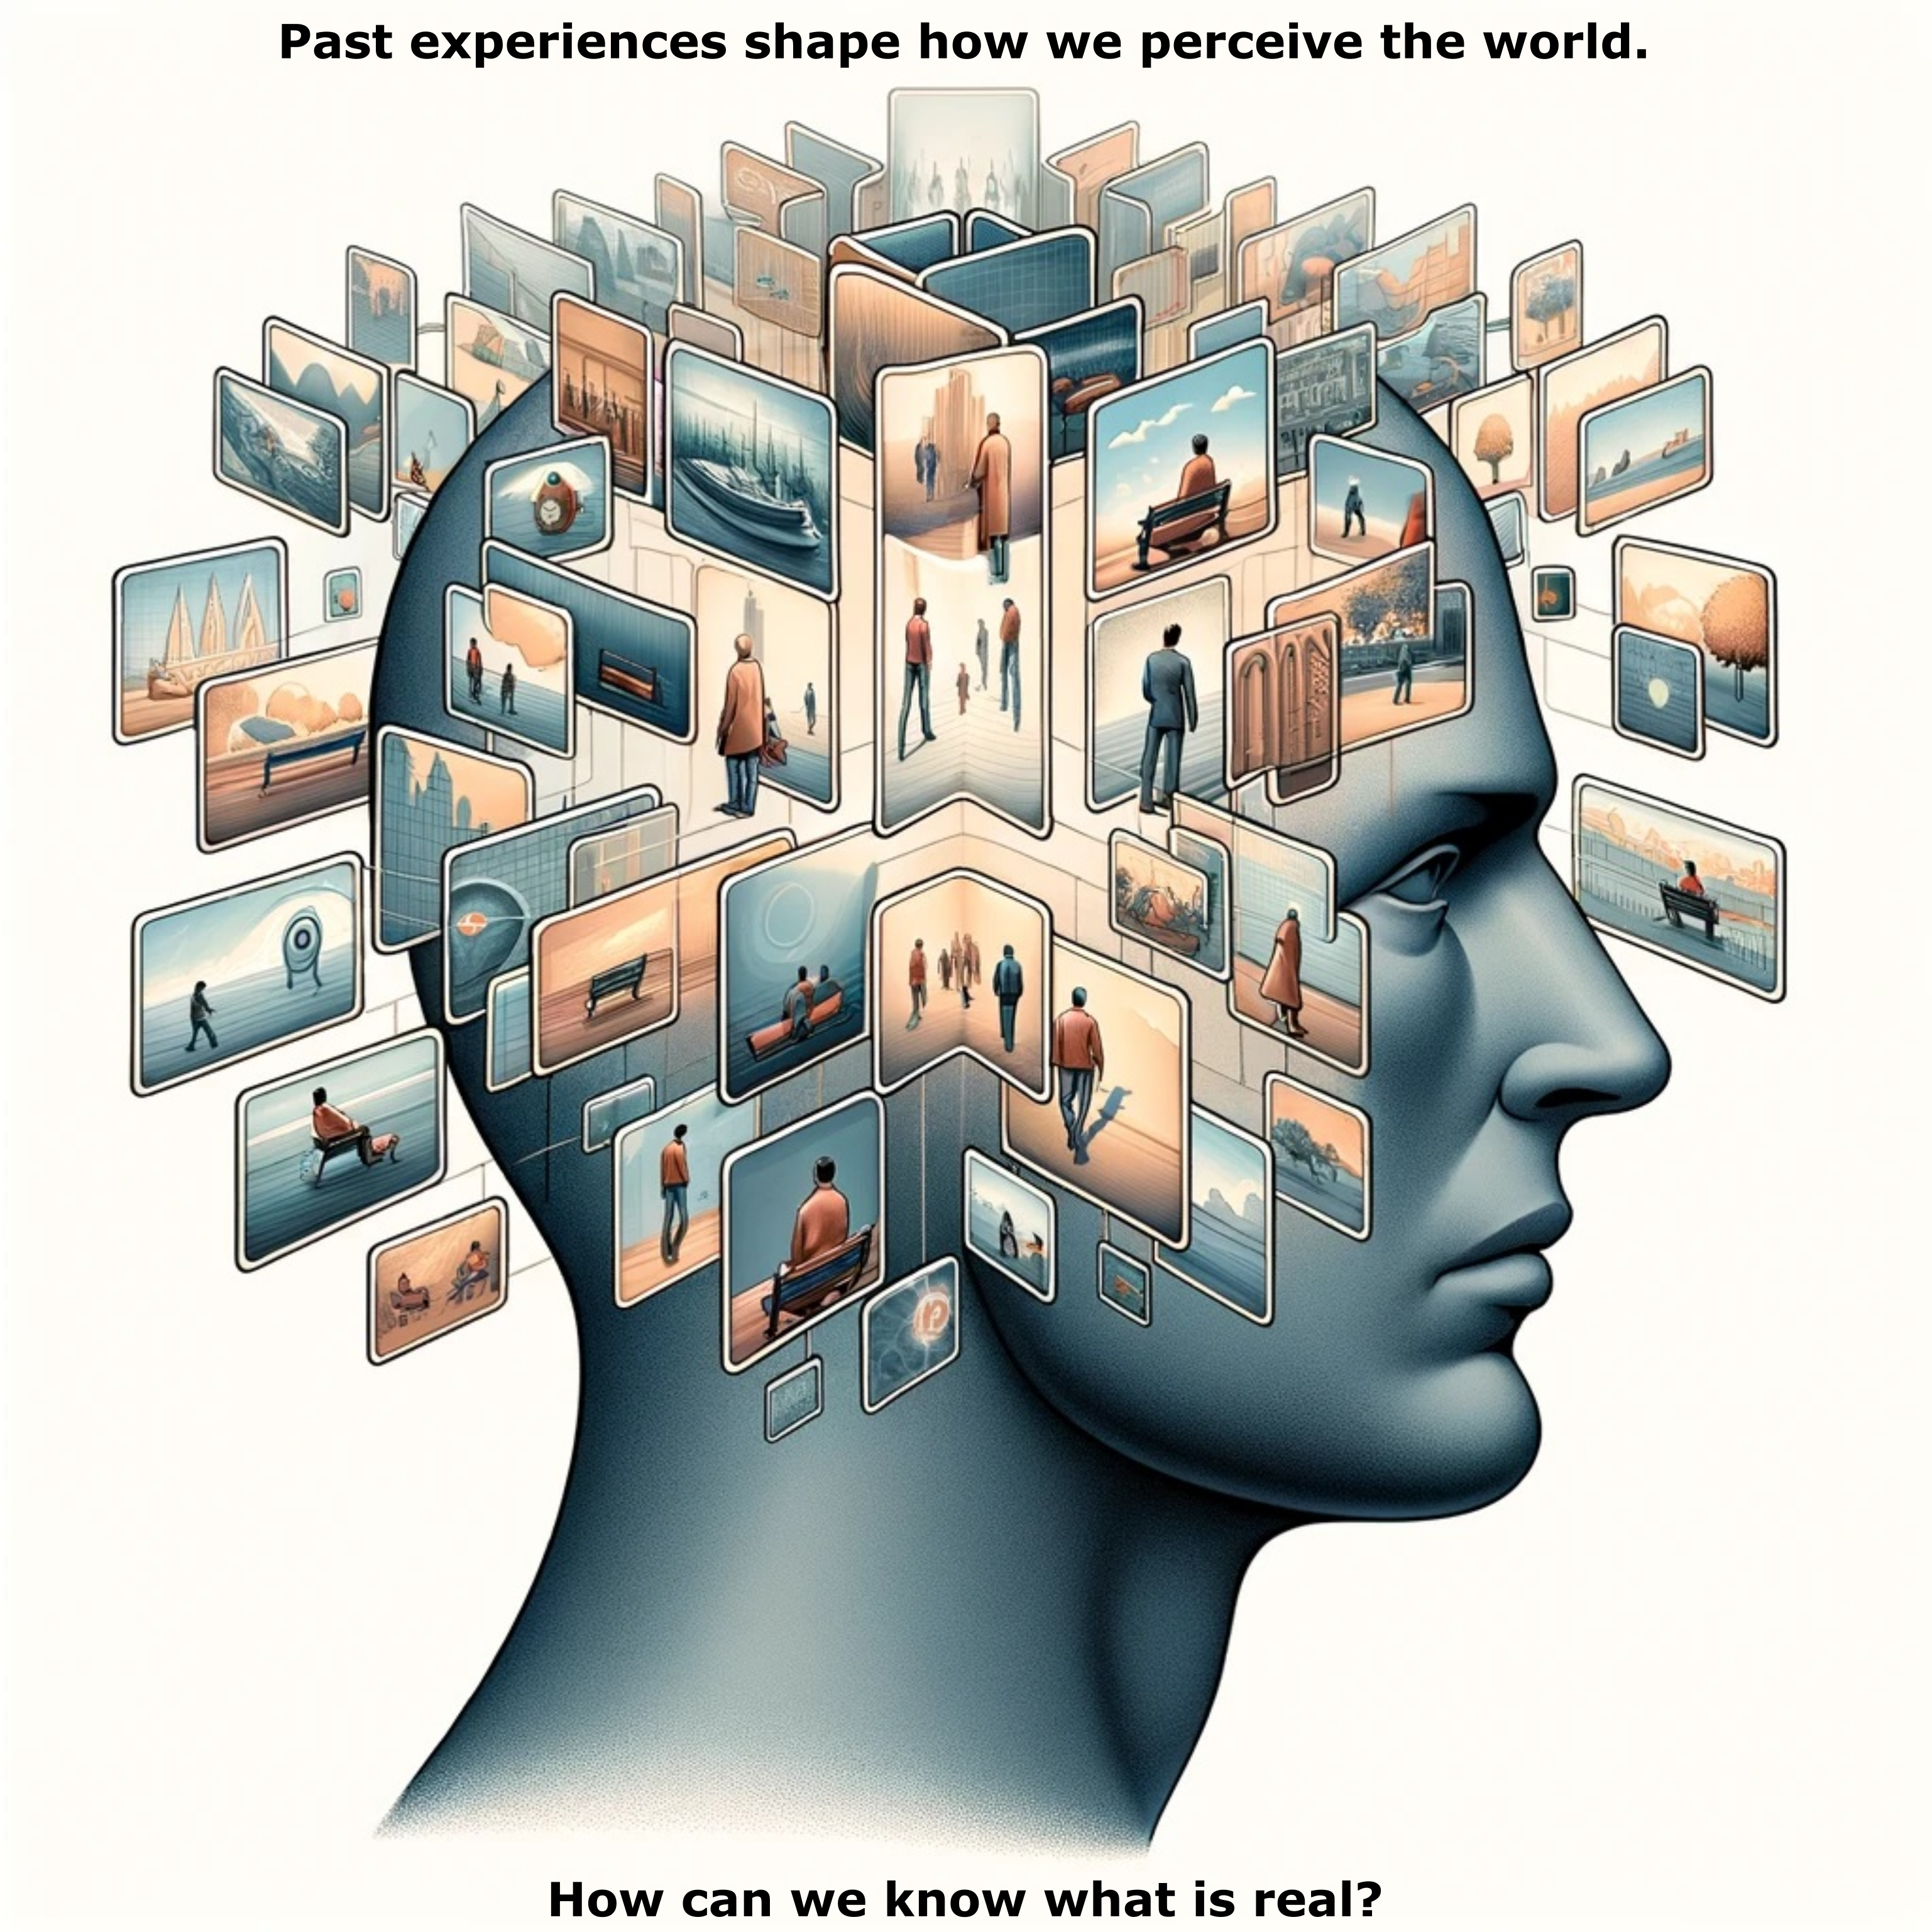ure as a striking image and plan to use it to advertise our article on twitter. If you think this is appropriate, we are happy if you use it. On twitter, this image will be accompanied by text that explains how it connects to our research. If you choose to publish this, it may be good if it goes along with our abstract.

The image (300 dpi) has been created with the help of DALLE-3. A web-search with Google image search revealed no evident copyright issues.